**Creating Microservices for account and loan:**

**AccountController.java:**

package com.cognizant.account.controller;

import org.springframework.web.bind.annotation.*;

import java.util.HashMap;

import java.util.Map;

@RestController

@RequestMapping("/accounts")

public class AccountController {

@GetMapping("/{number}")

public Map<String, Object> getAccountDetails(@PathVariable String number) {

Map<String, Object> account = new HashMap<>();

account.put("number", number);

account.put("type", "savings");

account.put("balance", 234343);

return account;

}

}

**AccountApplication.java:**

package com.cognizant.account;

import org.springframework.boot.SpringApplication;

import org.springframework.boot.autoconfigure.SpringBootApplication;

@SpringBootApplication

public class AccountApplication {

public static void main(String[] args) {

SpringApplication.run(AccountApplication.class, args);

}

}

**Output:**

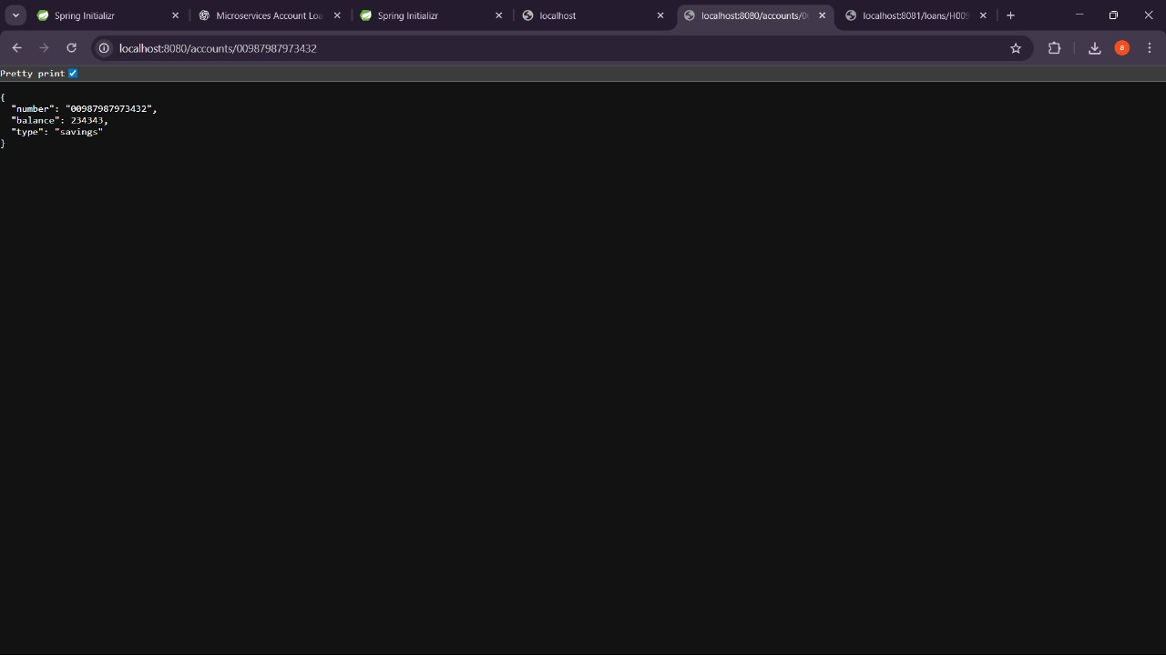

**LoanController.java:**

package com.cognizant.loan.controller;

import org.springframework.web.bind.annotation.*;

import java.util.HashMap;

import java.util.Map;

@RestController

@RequestMapping("/loans")

public class LoanController {

@GetMapping("/{number}")

public Map<String, Object> getLoanDetails(@PathVariable String number) {

Map<String, Object> loan = new HashMap<>();

loan.put("number", number);

loan.put("type", "car");

loan.put("loan", 400000);

loan.put("emi", 3258);

loan.put("tenure", 18);

return loan;

}

}

**LoanApplication.java:**

package com.cognizant.loan;

import org.springframework.boot.SpringApplication;

import org.springframework.boot.autoconfigure.SpringBootApplication;

@SpringBootApplication

public class LoanApplication {

public static void main(String[] args) {

SpringApplication.run(LoanApplication.class, args);

}

}

**Output:**

